Day in the Life of the Hudson River 10/13/22
Nyack Memorial Park, Nyack, NY
RIVER MILE: 28
Salt Front: ~RM75
Liberty Elementary School- George Mrsich
Ashley Curtis, and OSA
Rockland County Soil & Water District – Nicole Laible and Brianna Rosamilia
60 students & 15 adults
Latitude 41.08742 N & Longitude – 73.91576 W
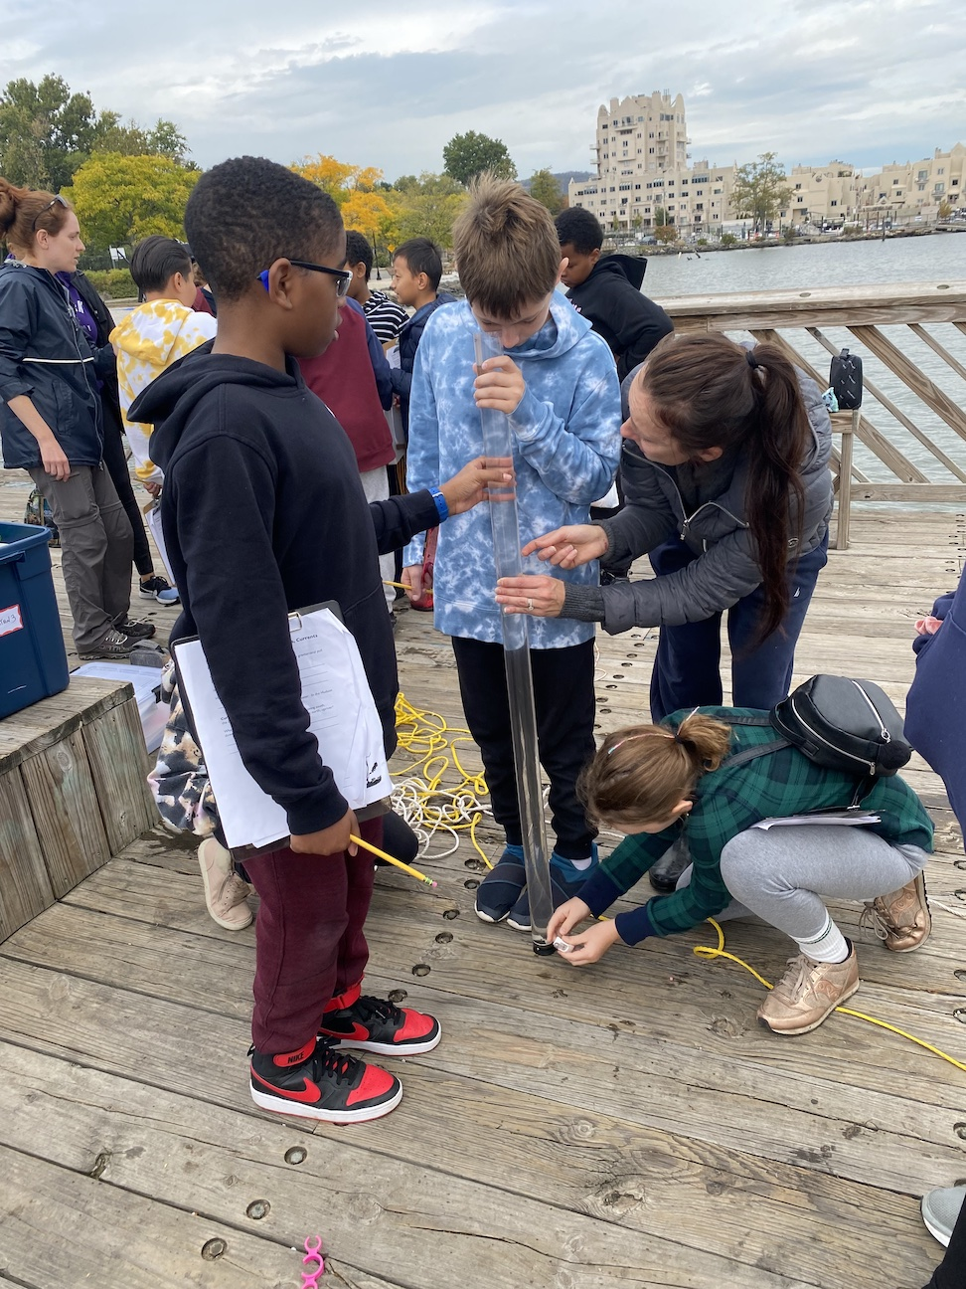 | 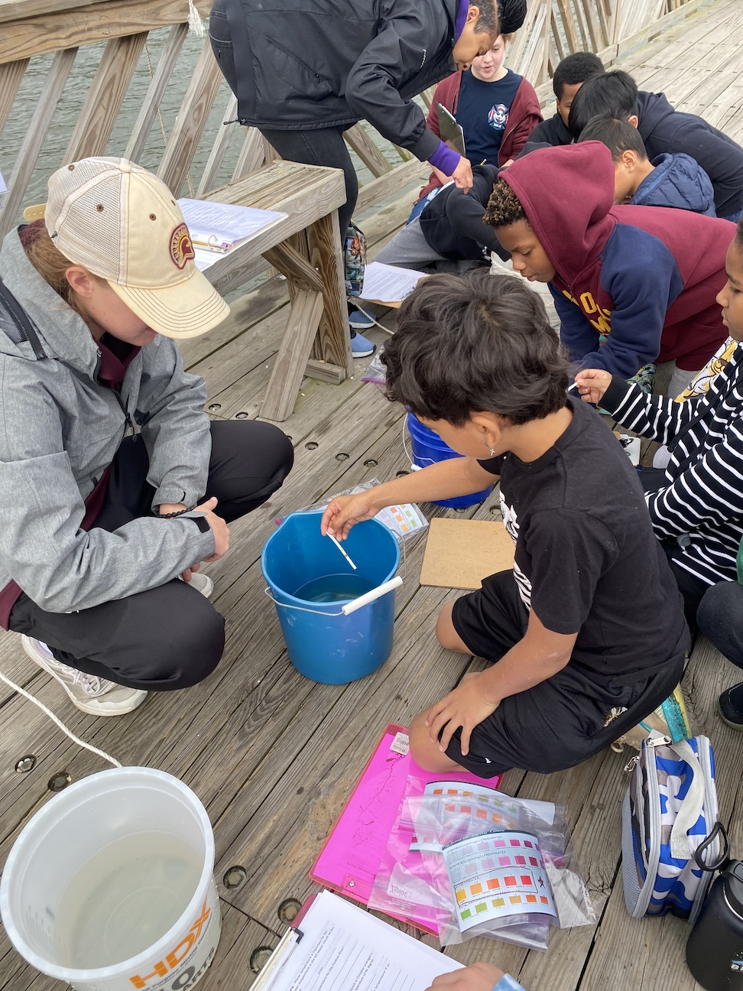 | 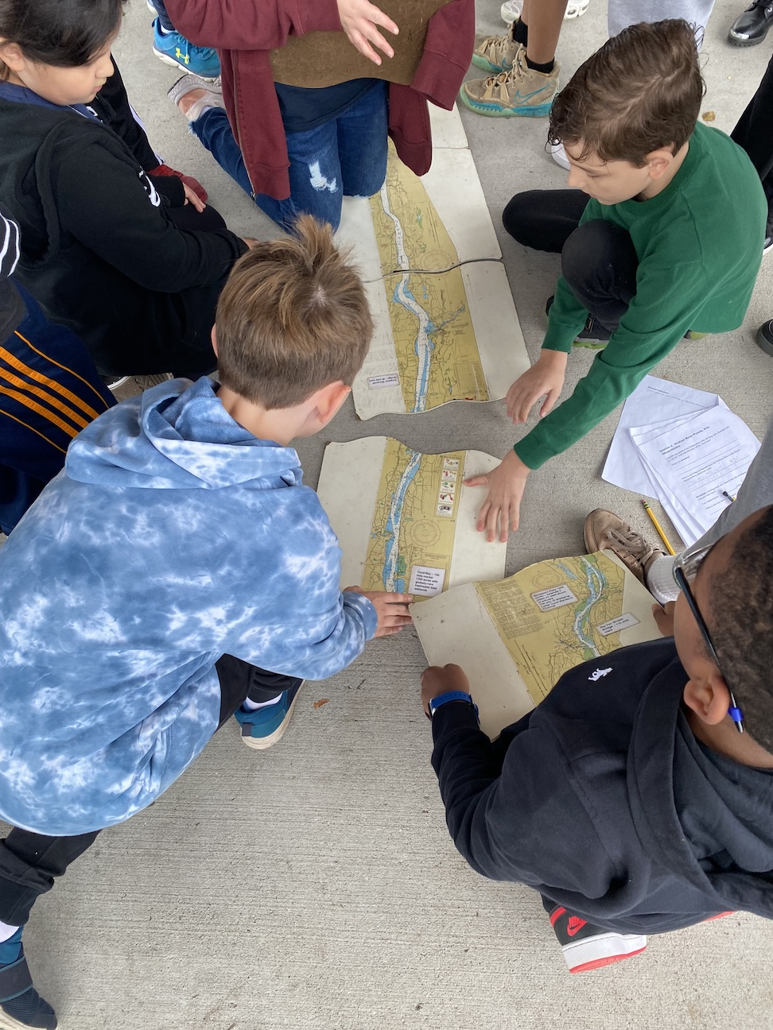 | 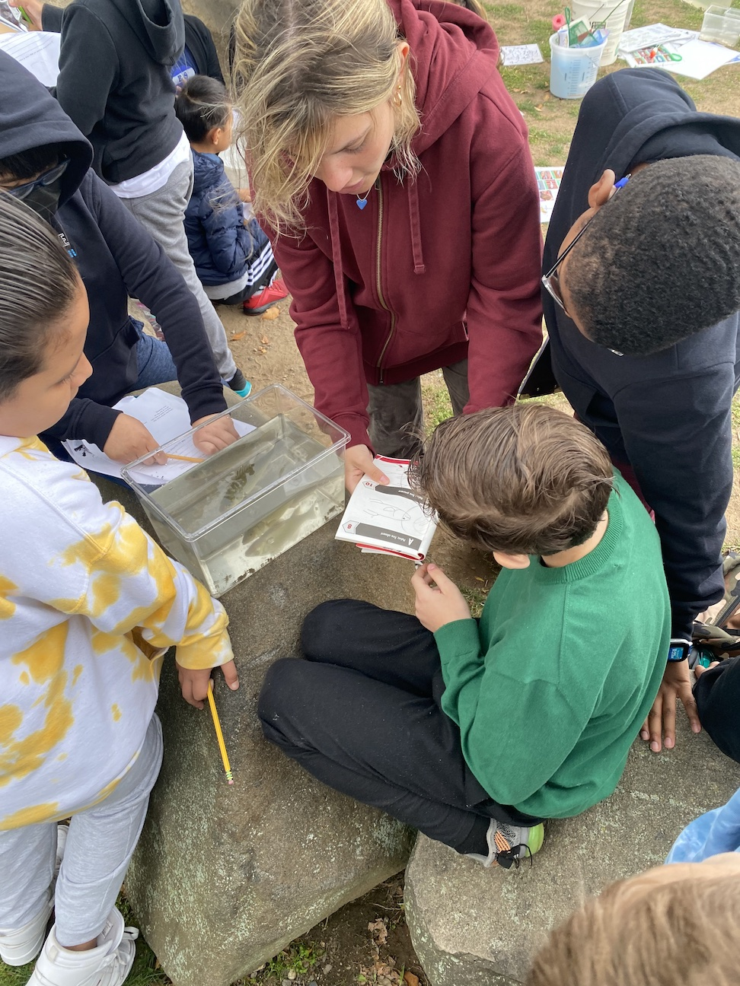

Location: Nyack Memorial Park, Nyack
Area: Drainage pipe forming stream that leads into Hudson River
Surrounding Land Use: Forested, beach, park
Sampling Site: Pier, forested, beach, altered banks, grassy, covered in vegetation, RipRap, pipe entering the water
Shoreline: 30% Sandy; 70% Rocky
Water: Choppy
River Bottom: muddy, sandy, rocky
*NR = Not read/recorded
ITEM |  | Time |  | Reading |  |  |  | Comments
Physical
Air Temperature- |  | 9:45 AM  10:30 AM  10:45 AM  11:15 AM |  | 21°C  20.5°C  20.5 °C  20°c |  |  | 70°F  69°F  69°F  68°F
Wind Speed: NR |  |  |  | Anemometer |  |  | Beaufort | Direction
Weather today |  | 9:30 AM |  | Overcast |  |  | No Rain
Weather the past 3 days: |  | Seasonal sunny weather past 3 days
Tides- measured down from pier |  | Time |  | Rising, Falling, Unchanged |  |  | Water Height (cm)
 |  | 9:45 AM  10:45 AM  11:15 AM |  | Rising  Rising  Rising |  |  | 269 cm  243 cm  240 cm
Current- |  | Time |  | Cm/sec |  | Knots | North/South | Ebb/Flood/Still
 |  | 9:45 AM  10:30 AM  10:45 AM  11:15 AM |  | 12.6  NR  14.3  18.7 |  | NR | North  North  North  North | Flood  Flood  Flood  Flood
Water Temperature- |  | 9:45 AM  10:30 AM  10:45 AM  11:15 AM |  | 17.8°C  18.3°C  18.3°C  18.3°C |  |  | 64°F  65°F  65°F  65°F
Turbidity- Long Sight Tube (120 cm) |  | 10:30 AM  10:45 AM  11:15 AM |  | 43,35,40,47  45,46,52  35,45,57,39 |  |  | Average: 41.25 cm  47.6 cm  44 cm
Chemical
Salinity- hydrometer |  | 9:45 AM  10:30 AM  10:45 AM  11:15 AM |  | 12 ppt  14 ppt  12 ppt  11 ppt |  |  | 12:15 PM Salinity read with HR quantabs 8.2 | 3854 ppm Cl-  6962 ppm Total Salinity
Standardized Salinity – HR Quantabs |  | 11:50 AM |  | Total Salinity  8,536 ppm |  |  | HR quantab 8.6
DO – Hach Kit |  | Time  12:15 PM |  | Temp  17.2°C |  |  | ppm DO  8 ppm | % saturation  82%
pH – Sticks |  | 9:45 AM  10:30 AM  10:45 AM  11:15 AM |  | 7.2  7.2  7.2  7.5 |  |  | Hach Kit | 8
Nitrates- NR
Phosphates- NR
Alkalinity- NR
Biological
Fish – Seine |  | Number |  | Name |  |  | Length of longest | Length of smallest
8:00-9:15 AM |  | 15 |  | Atlantic Silverside
Fish Totals |  | TOTAL:15 |  | Diversity: 1 |  |  | *@ 8:30 AM an angler provided | 1 Snapping Turtle 30.4 cm  2 Channel Catfish  (36 cm & 25 cm)
Macroinvertebrates |  | Number |  | Name |  |  | Length of longest | Length of smallest
 |  | 5  3 |  | Blue Crab  Ctenophore sp. |  |  | (1M, 1F)
Macroinvertebrate Totals |  | TOTAL: 8 |  | Diversity: 2 |  |  | *rest of blue crabs too small to ID sex
Sediment Core - NR
Length | H2S smell |  | Oxid Top |  | Oil |  | Grain Size | Other Features
Boats-NR
 | Time |  | Name |  | Color |  | North/Southbound | Light/Loaded

